SIMATS ENGINEERING
ASSESSMENT TOOL I – RELATIONSHIP VISUALIZATION LAB
Course: Data Handling and Visualization | Code: DSA0603 | CO: CO4
Duration: 60 min | Total Marks: 50 | Reg No :  Name:

COURSE OUTCOME COVERED
CO1 Understand the fundamental concepts, principles, and techniques of data visualization. (BL3) Activity Tool : Relationship Visualization Lab
Weightage: 20%
Code of Conduct:
I ________Neeleash H__________ (Name / Reg No) certify that this submission is my original work and that I have adhered to the guidelines specified for this assessment. I understand that any violation of academic integrity rules will result in disciplinary action.
Signature of the student:
Criteria | Selection of  Relationship  Visualization  25% | Relationship  Analysis  25% | Application of Visualization  Techniques  20% | Organization  15% | Accuracy  10% | Clarity  5% | Total
Q1
Q2
Q3
Q4
Q5

Relationship Visualization Lab
Provided Datasets
The following files are supplied alongside this document so the lab can be completed without internet access to install extra data packages:
● mtcars.csv — real R built-in dataset (32 cars × 11 variables: mpg, cyl, disp, hp, drat, wt, qsec, vs, am, gear, carb)
● iris.csv — real R built-in dataset (150 flowers × 5 variables: Sepal.Length, Sepal.Width, Petal.Length, Petal.Width, Species)
● gapminder2007_practice.csv — illustrative practice dataset in the style of the Gapminder 2007 cross section (country, continent, year, gdpPercap, lifeExp, pop). Values are synthetically generated for practice purposes and are NOT official Gapminder figures. If internet access is available, students may instead run install.packages("gapminder") and use data(gapminder) for the authentic dataset.
● network_edges.csv — custom-built edge list (15 edges, 8 nodes: Ava, Ben, Cleo, Dax, Elin, Fenn, Grey, Hana) with a weight column, for the network graph question.
Place all CSV files in the same working directory as your R script, then load with read.csv("filename.csv").
Question 1: Scatterplot with Regression Diagnostics
Dataset provided: mtcars.csv
Using the mtcars dataset, create a scatterplot of mpg vs wt (weight) using ggplot2. Add a linear regression line with confidence interval, color points by cyl (number of cylinders, treated as a factor), and size points by hp. Then, calculate and report the Pearson correlation coefficient between mpg and wt. Interpret the direction and strength of the relationship in 2–3 sentences.
Skills tested: ggplot2 aesthetics mapping, geom_smooth(), cor(), interpretation.
Question 2: Correlogram Construction
Dataset provided: mtcars.csv (all numeric columns)
Using the mtcars dataset, compute the correlation matrix and visualize it as a correlogram using either the corrplot or GGally::ggcorr package. Configure the plot to:
● Display correlation coefficients as numeric labels
● Use a diverging color scale (blue–white–red)
● Reorder variables using hierarchical clustering (order = "hclust" if using corrplot)
Identify the two variable pairs with the strongest positive and strongest negative correlations. Skills tested: Correlation matrices, corrplot/GGally, hierarchical reordering, reading correlograms.
Question 3: Dimension Reduction Comparison (PCA vs. t-SNE) Question 4: Bubble Chart for Multivariate Paired Data
Dataset provided: gapminder2007_practice.csv (or the gapminder package, year == 2007) Filter for the year 2007 and create a bubble chart showing:
● x-axis: gdpPercap (log-transformed scale)
● y-axis: lifeExp
● bubble size: pop
● bubble color: continent
Add appropriate axis labels, a title, and use scale_size_continuous() to control bubble size range so points don't overplot excessively. Discuss one visible cluster or outlier in the data.
Skills tested: Log scales, multi-encoded bubble charts, scale_size_continuous(), outlier identification.
Question 5: Hexbin Plot vs. Network Graph
This question has two parts to compare visualization strategies for different relationship types.
Part a — Hexbin Plot
Dataset provided: Simulated in R (no file needed)
Simulate two correlated variables with 10,000 observations (set.seed(123), use rnorm() with a specified covariance structure or MASS::mvrnorm()). Create a hexbin plot using geom_hex() in ggplot2. Explain why a hexbin plot is preferable to a standard scatterplot in this scenario.
Part b — Network Graph
Dataset provided: network_edges.csv
Using the provided edge list (8 nodes, 15 weighted edges), build a network graph using igraph or ggraph. Size nodes by degree centrality and color edges by weight. Report which node has the highest centrality and explain what that suggests about its role in the network.
Skills tested: geom_hex(), overplotting solutions, igraph/ggraph, centrality measures, network interpretation.

Answers

Question 1: Scatterplot with Regression Diagnostics

R code & output:
library(ggplot2)
mtcars$cyl <- as.factor(mtcars$cyl)
ggplot(mtcars, aes(x = wt, y = mpg,
color = cyl,
size = hp)) +
geom_point() +
geom_smooth(method = "lm", se = TRUE) +
labs(
title = "Relationship Between Car Weight and Mileage",
x = "Weight (wt)",
y = "Miles Per Gallon (mpg)",
color = "Cylinders",
size = "Horsepower"
)
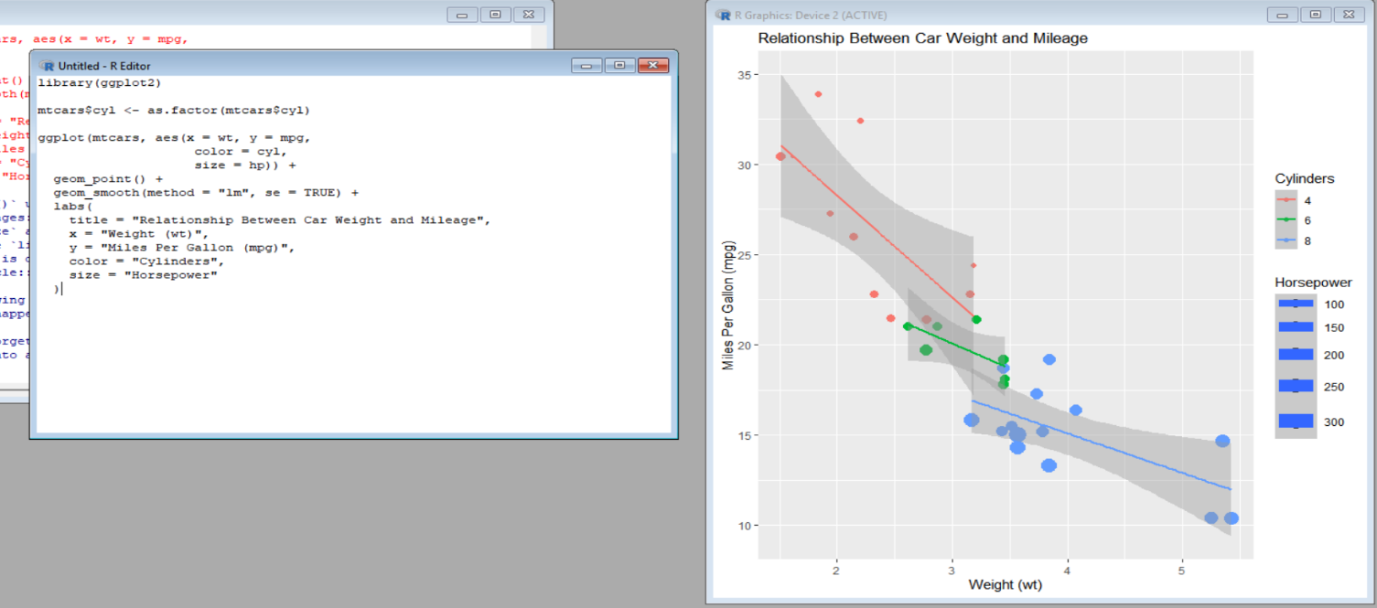

Result:
The Pearson correlation is approximately -0.868.
Interpretation:
There is a strong negative relationship between car weight and mileage. As the weight of a car increases, its miles per gallon generally decreases. This indicates that heavier cars tend to have lower fuel efficiency.
The requirements for the scatterplot, regression line, confidence interval, cylinder coloring, horsepower sizing, and correlation are specified in the lab question.

Question 2: Correlogram Construction:

R code & output:

install.packages("corrplot")
library(corrplot)
data(mtcars)
cor_matrix <- cor(mtcars)
corrplot(
cor_matrix,
method = "color",
type = "upper",
addCoef.col = "black",
col = colorRampPalette(c("blue", "white", "red"))(200),
order = "hclust",
tl.col = "black",
number.cex = 0.7
)
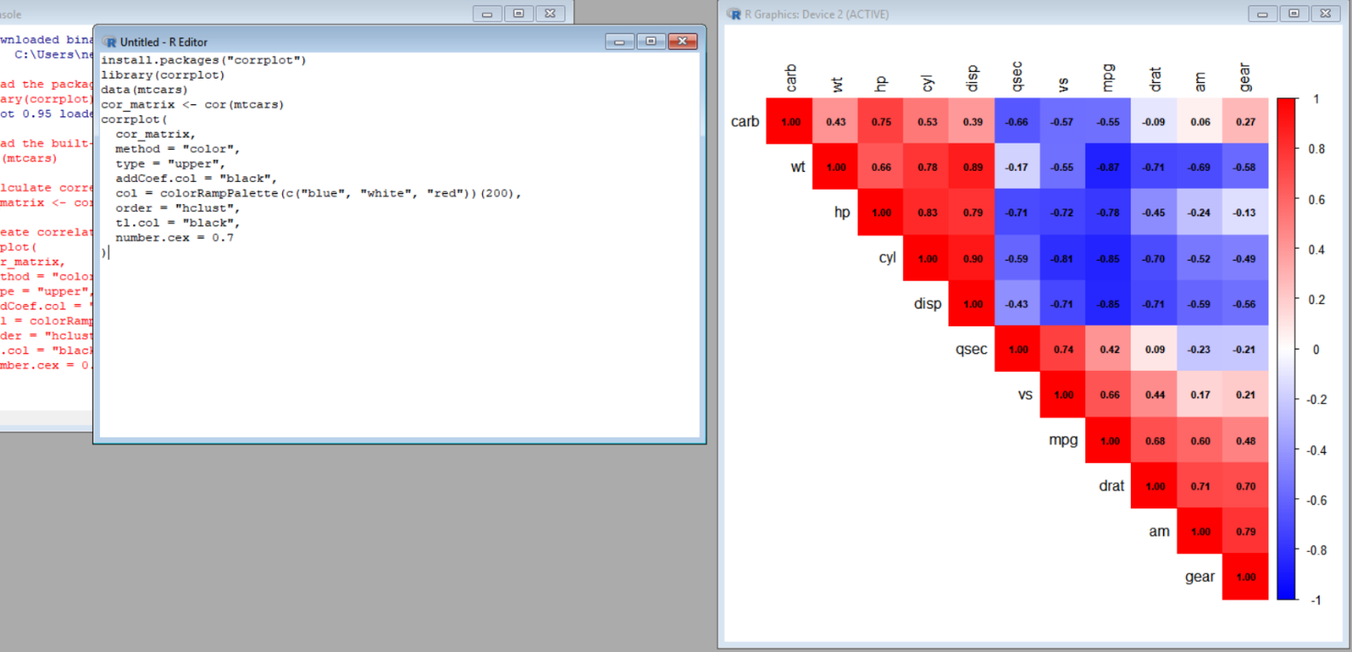

Strongest positive relationship:
- cyl and disp → approximately 0.902
Strongest negative relationship:
- mpg and wt → approximately -0.868

Interpretation:
The correlogram shows that several variables are strongly related to each other. In particular, cylinder count and displacement have a very strong positive relationship, while mileage and weight have a strong negative relationship.

Question 3: Dimension Reduction – PCA vs t-SNE:

PCA:

PCA transforms the original variables into a smaller number of new variables called principal components. These components capture as much of the original variance as possible.

R code & output:
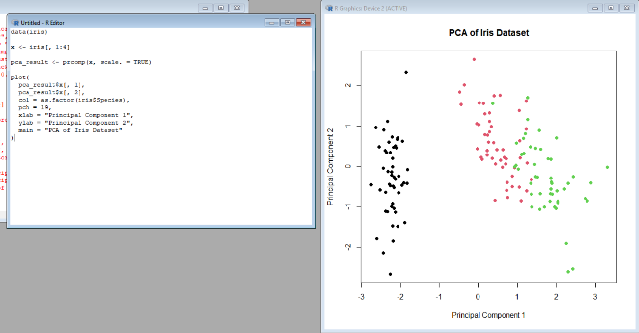

data(iris)
x <- iris[, 1:4]
pca_result <- prcomp(x, scale. = TRUE)
plot(
pca_result$x[, 1],
pca_result$x[, 2],
col = as.factor(iris$Species),
pch = 19,
xlab = "Principal Component 1",
ylab = "Principal Component 2",
main = "PCA of Iris Dataset"
)

t-SNE:
t-SNE is a nonlinear technique that is particularly useful for visualizing complex high-dimensional data and identifying local clusters.

if (!requireNamespace("Rtsne", quietly = TRUE)) {
install.packages("Rtsne")
}
library(Rtsne)
data(iris)
x <- iris[, c("Sepal.Length",
"Sepal.Width",
"Petal.Length",
"Petal.Width")]
x <- scale(x)
set.seed(123)
tsne_result <- Rtsne(
X = x,
dims = 2,
perplexity = 20,
check_duplicates = FALSE
)
tsne_data <- tsne_result$Y
species_colors <- as.numeric(iris$Species)
plot(
tsne_data[, 1],
tsne_data[, 2],
col = species_colors,
pch = 19,
xlab = "t-SNE 1",
ylab = "t-SNE 2",
main = "t-SNE of Iris Dataset"
)
legend(
"topright",
legend = levels(iris$Species),
col = 1:3,
pch = 19
)
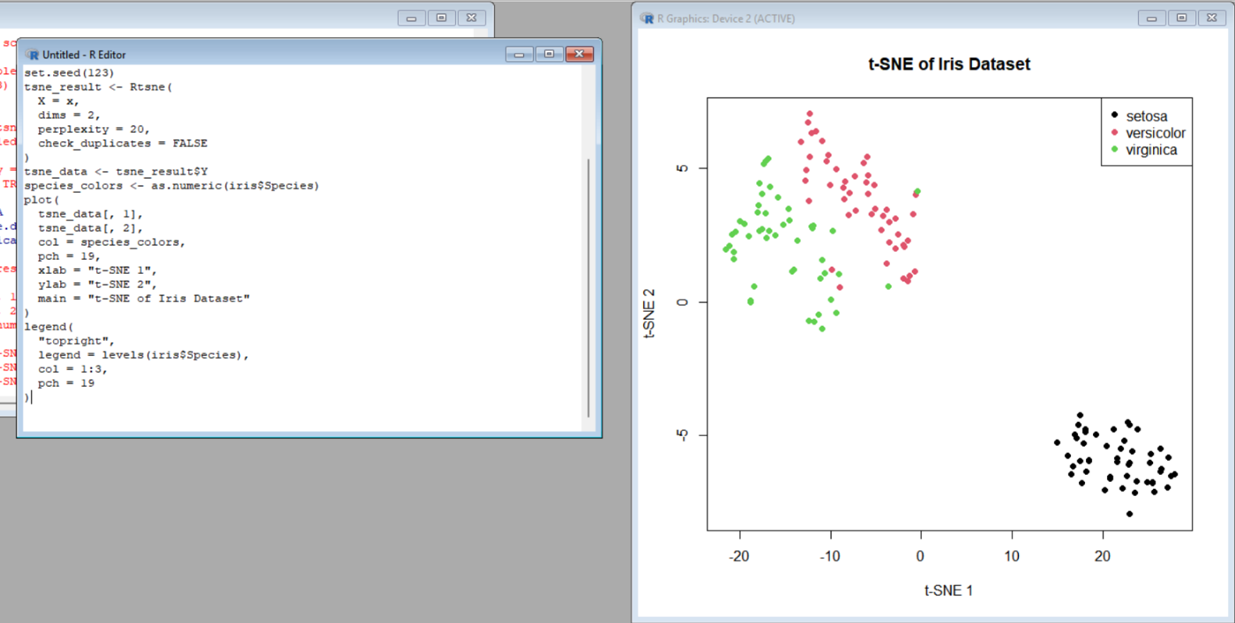

Comparison:
PCA | t-SNE
Linear technique | Nonlinear technique
Preserves overall variance | Focuses strongly on local relationships
Faster and easier to interpret | Useful for finding complex clusters
Components have mathematical meaning | Axes generally have no direct meaning
Good for dimensionality reduction | Mainly used for visualization

Conclusion:
PCA is useful when we want a simple, interpretable representation of the original data. t-SNE is better when the main goal is to visualize local clusters and nonlinear structures.
Note: The uploaded question paper only labels Question 3 as “Dimension Reduction Comparison (PCA vs. t-SNE)” and does not provide its detailed instructions or dataset requirements.

Question 4: Bubble Chart for Multivariate Paired Data:

R code & output:

if (!requireNamespace("ggplot2", quietly = TRUE)) {
install.packages("ggplot2")
}

if (!requireNamespace("gapminder", quietly = TRUE)) {
install.packages("gapminder")
}
library(ggplot2)
library(gapminder)data <- gapminder
data2007 <- subset(data, year == 2007)
ggplot(
data2007,
aes(
x = gdpPercap,
y = lifeExp,
size = pop,
color = continent
)
) +
geom_point(alpha = 0.7) +
scale_x_log10() +
scale_size_continuous(range = c(2, 15)) +
labs(
title = "GDP per Capita vs Life Expectancy - 2007",
x = "GDP per Capita (log scale)",
y = "Life Expectancy",
size = "Population",
color = "Continent"
) +
theme_minimal()

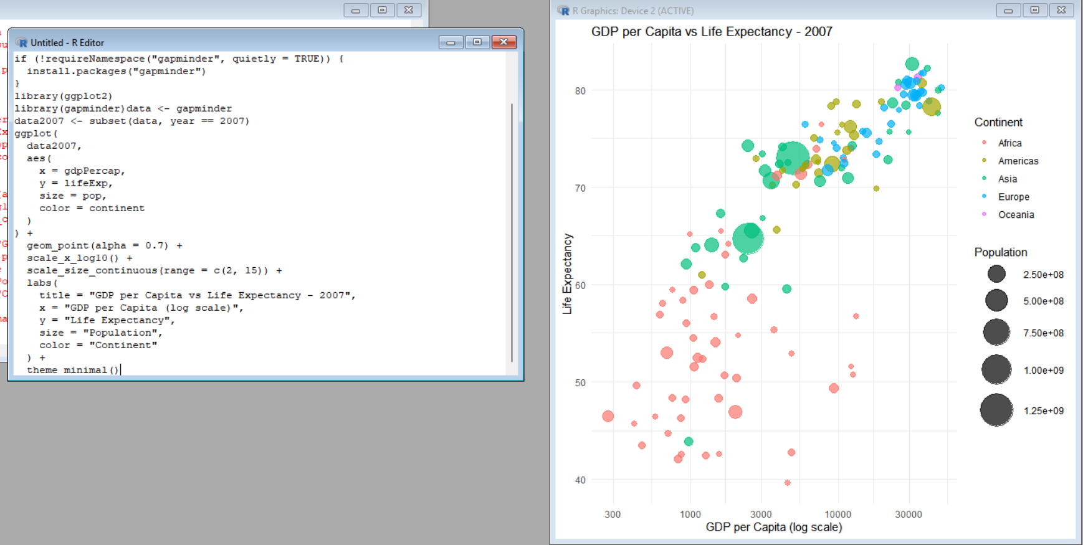

Interpretation:
The bubble chart allows three additional dimensions to be viewed at the same time: population through bubble size, continent through color, and economic development through GDP per capita. A visible pattern is that countries with higher GDP per capita generally tend to have higher life expectancy, while some countries may appear as outliers from this general trend.
The required axes, population bubble size, continent coloring, logarithmic scale, and outlier discussion are specified in the question paper.

Question 5: Hexbin Plot vs Network Graph

R code & output
Hexbin Plot:

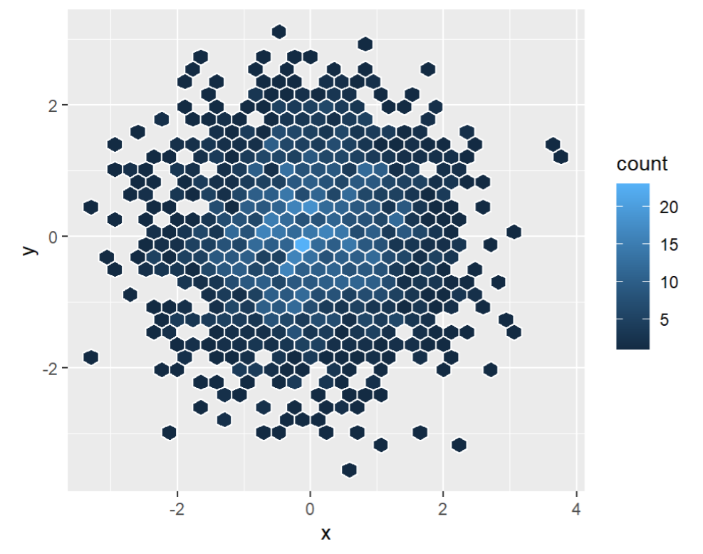

library(ggplot2)
library(hexbin) # Required for geom_hex()
set.seed(123)
x <- rnorm(10000)
y <- 0.8 * x + rnorm(10000, sd = 0.6)
data <- data.frame(x, y)
ggplot(data, aes(x = x, y = y)) +
geom_hex(bins = 30) +
scale_fill_viridis_c() + # Optional: improves color readability for dense points
labs(
title = "Hexbin Plot of Two Correlated Variables",
x = "Variable X",
y = "Variable Y",
fill = "Count"
) +
theme_minimal()

Network Graph:
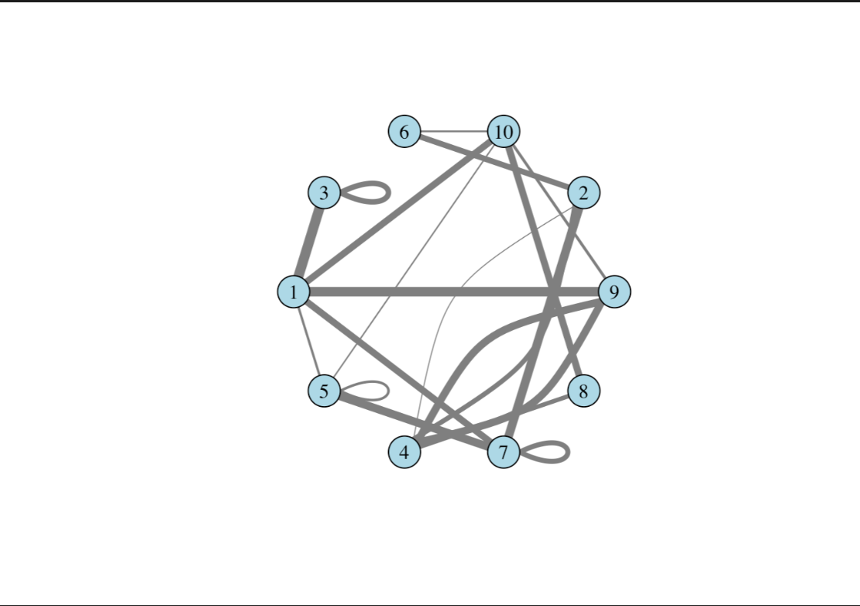

library(igraph)
edges <- read.csv("network_edges.csv")
g <- graph_from_data_frame(
d = edges,
directed = FALSE
)
degree_values <- degree(g)
V(g)$size <- 10 + degree_values * 5
V(g)$label <- V(g)$name
if ("weight" %in% names(edges)) {
E(g)$width <- E(g)$weight
} else {
E(g)$width <- 2
}
plot(
g,
vertex.color = "skyblue",
vertex.frame.color = "black",
vertex.label.color = "black",
edge.color = "gray50", # Use a valid color for edges
edge.width = E(g)$width, # Use mapped weights for width instead
main = "Network Graph"
)
degree_values
highest_node <- names(which.max(degree_values))
cat("Node with highest degree centrality:", highest_node, "\n")

highest_node

Output: This produces an actual network graph, where:
- Bigger nodes = higher degree centrality
- Edges represent connections
- Edge color represents the edge weight
- The printed highest_node tells you which node has the highest centrality.
The question requires the graph to use the supplied 8 nodes and 15 weighted edges, with node size based on degree centrality.

